**NPM Packages/Library/Framework**

**Front-End**

* React
* Material UI
  + <https://mui.com/>
  + <https://react-bootstrap.github.io/>
  + https://getbootstrap.com/
* *Redux*
  + [*https://redux.js.org/*](https://redux.js.org/)

**Back-End**

* Nodemon
* Axios
* Express
  + compression
* Morgan

**Database**

* Relational
  + Postgresql
* ORM
  + Sequelize

**Test / Continuous Integration**

* Jest DOM
* CircleCI
* Github Actions

**Others**

* Dotenv
* Possible Bundlers
  + Vite
    - <https://vitejs.dev/guide/#scaffolding-your-first-vite-project>
  + Create-react-app with Express back end
    - <https://medium.com/@dceddia/create-react-app-with-an-express-backend-9fbf7a2e0b59>
    - 1) $npm i -g create-react-app
    - 2) $create-react-app client
    - 3) 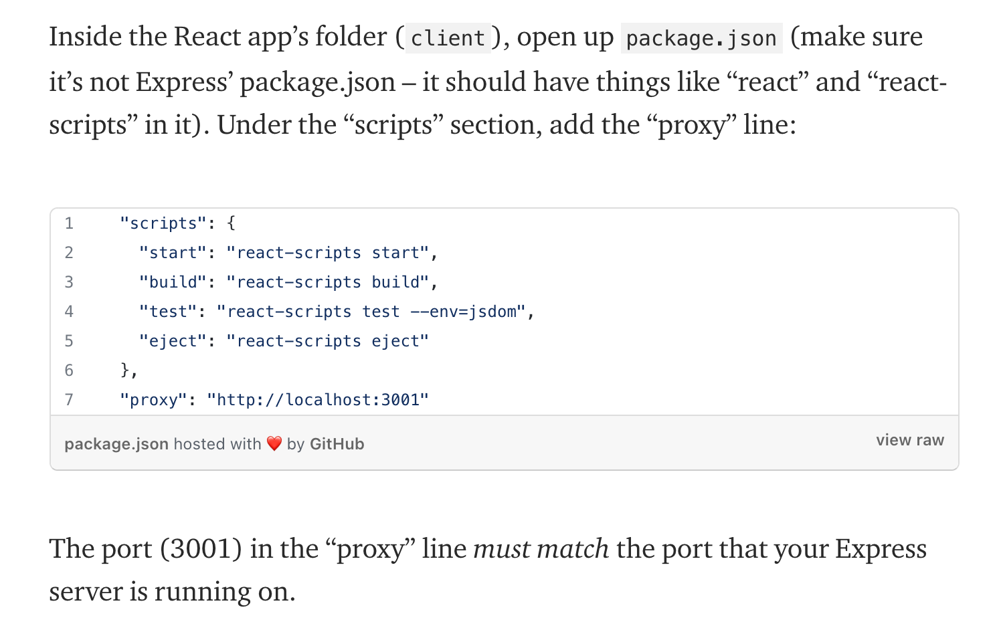
* Eslint (airbnb config)
  + https://www.npmjs.com/package/eslint-config-airbnb
* Proxy Server (Reach Goal)
  + Nginx for handling compression, routing and caching
  + Future proof for scalability

**Authorization**

Generic login button opens a modal in which you can sign up via email or social.

Email login requires auth token to be generated and stored and a session manager.

* ~~PassportJS~~
  + [~~http://www.passportjs.org/docs/~~](http://www.passportjs.org/docs/)
  + ~~Passport also has twitter auth provider if we want to integrate that as well~~
* Firebase
* Twilio?
  + <https://www.twilio.com/verify>
* <https://developers.google.com/identity/protocols/oauth2>
  + https://www.npmjs.com/package/react-google-login
* <https://developers.facebook.com/docs/facebook-login/>
  + <https://www.npmjs.com/package/react-facebook>

**Deployment**

* AWS

**GeoLocation**

https://ipstack.com/